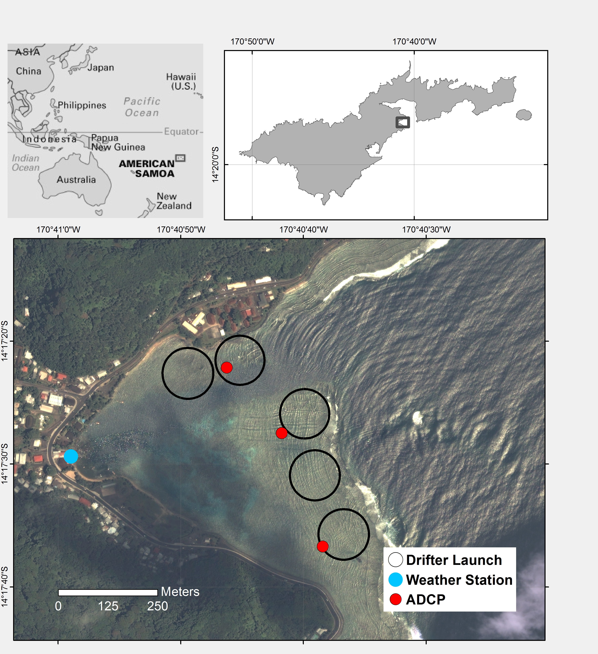

Figure 1. Data collection locations in Faga'alu Bay. Wind speed and direction were recorded at the weather station (Weather Station), acoustic current profilers were deployed at three locations (ADCP) for one week to measure current speed and direction, and GPS-logging drifters were deployed thirty times (January to March, 2014) from five launch zones (Drifter Launch).

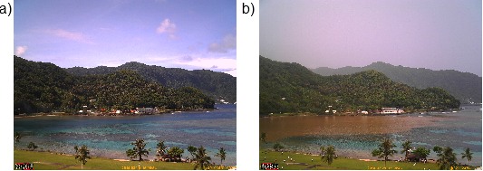

Figure 2. Faga'alu Bay under storm and non-storm conditions. a) Image of the embayment on a typical, rain-free day. The darker areas of the bay are live coral, and the light areas are deeper pools with carbonate sand bottom. b) Image of a flood plume (2/21/14) in the northern portion of the bay following a heavy precipitation event: 51 mm in 2 h. Plumes usually persist for several hours, and rarely are seen after 24h due to the flushing of water through the ava channel and out to sea.

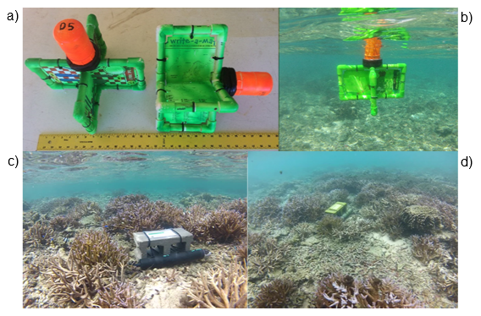

Figure 3. Five GPS-logging drifters and three acoustic current profilers were deployed on the reef flat in Faga'alu. TOP: Images of the shallow-water drifters a) on land, and b) deployed in the field. BOTTOM: Images of the acoustic current profilers deployed on the southern reef flat (AS1).

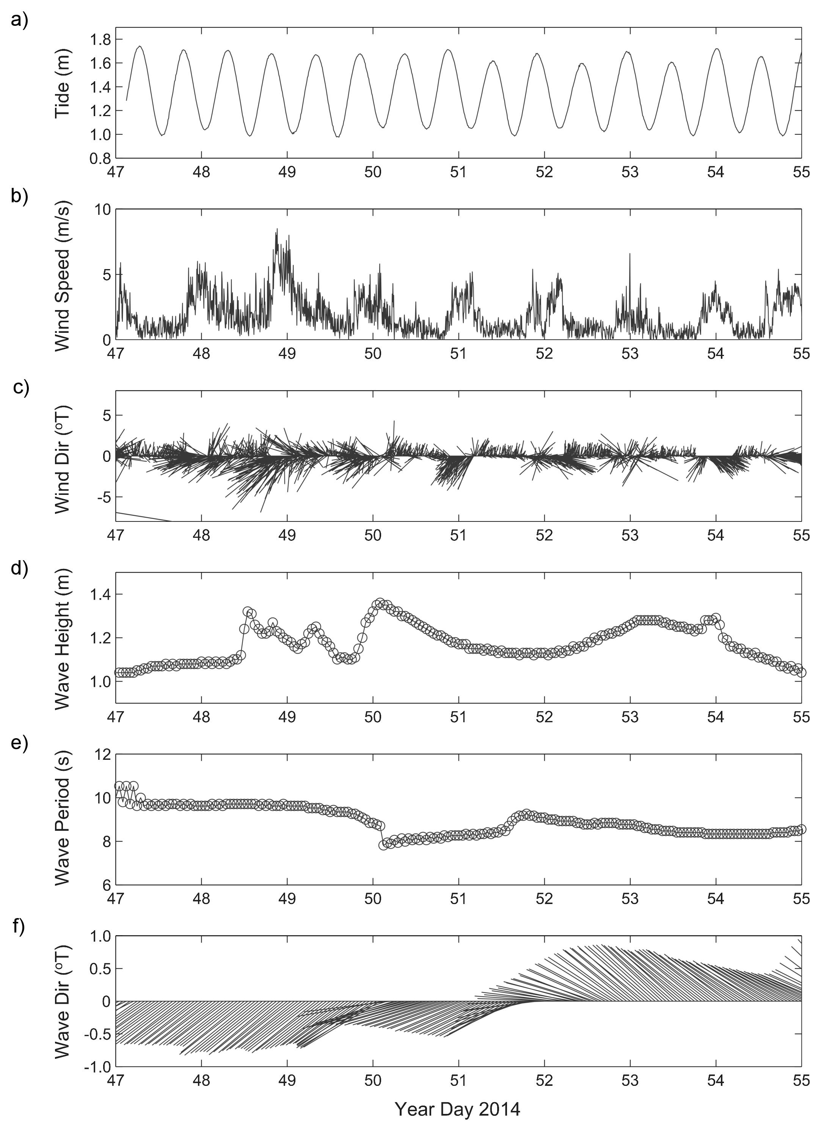

Figure 4. Time series of physical forcing data was used to define end-member forcing conditions for analysis. Forcing data included: a) tide stage, b) wind speed, c) wind direction from NDBC station NSTP6, d) wave height, e) wave period, and f) wave direction from NOAA WW3. Day 47=16 Feb 2014, Day 54=23 Feb 2014.

|  |  |  |  |
| --- | --- | --- | --- |
| **Table 1.** End member periods | | | |
| End member | Year Day 2014 | Gregorian Day (UTC) | Gregorian Day (Local) |
| Tide/Calm | 50-51 | 2/19-2/20 | 2/18-2/19 |
| Wind | 47-49 | 2/16-2/18 | 2/15-2/17 |
| Wave | 52-55 | 2/21-2/24 | 2/20-2/23 |

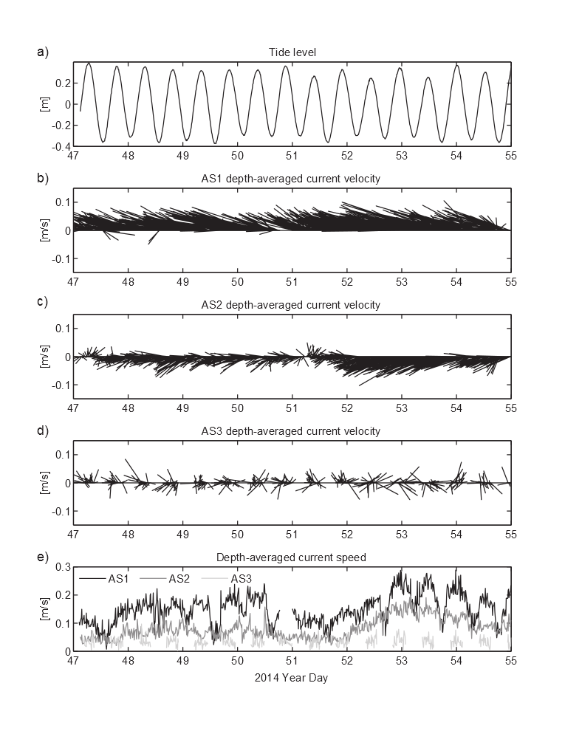

Figure 5. Acoustic current profilers (ADCP) at three locations on the reef flat recorded water flow for one week. Time series of tide (a) and water flow measured by the acoustic current profilers at the southernmost point, AS1 (b), the central part of the reef, AS2 (c), and northern reef, AS3 (d). At AS3 (d), water depths at low tide were too shallow to measure flow data. Note the variations in current speeds both in space and time due to the different forcing conditions (e).

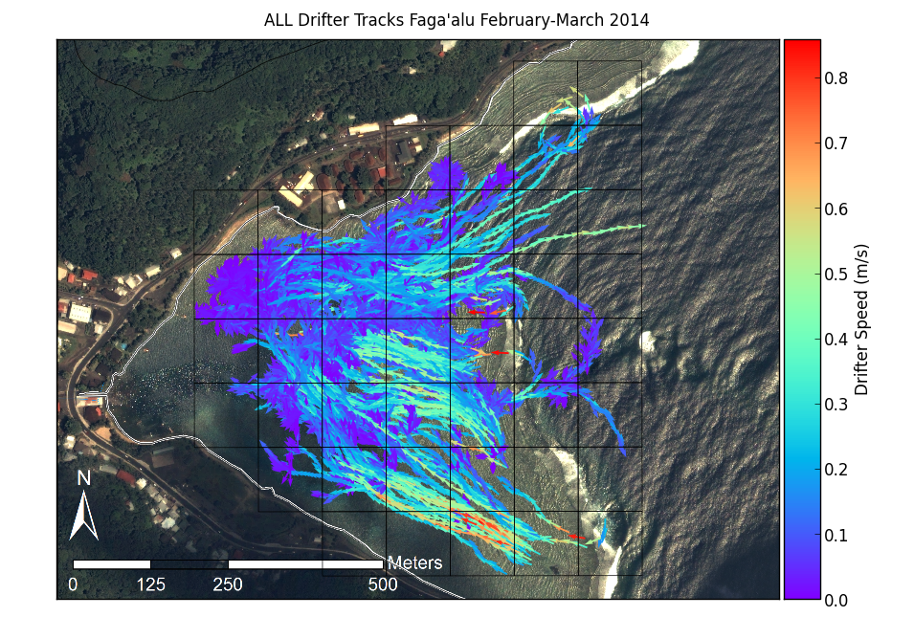

Figure 6. Map of all drifter tracks, colored by speed (m/s), recorded during the experiment.

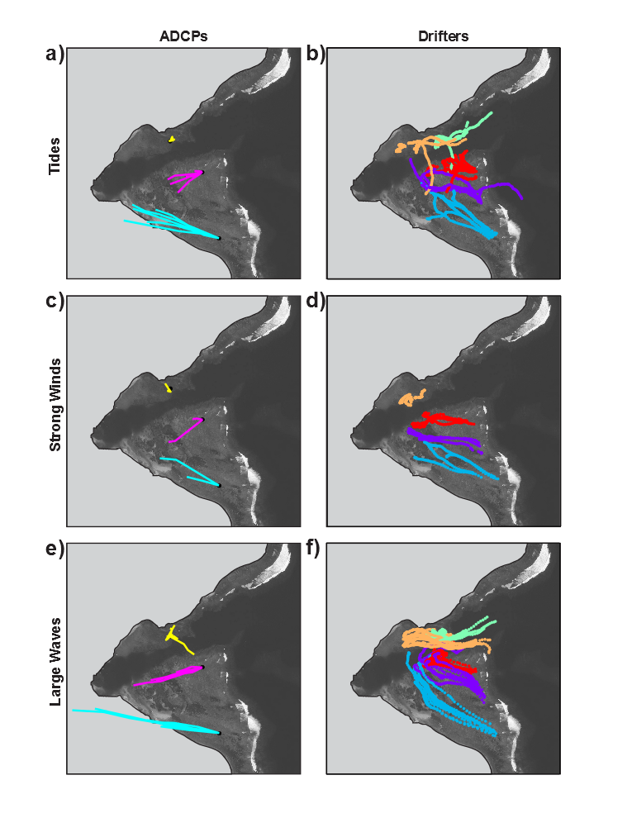

Figure 7. Progressive vectors calculated from acoustic current profiler (ADCP) data, compared to drifter tracks under end-member forcing conditions: a-b) Tide, c-d) Wind, and d-f) Wave .

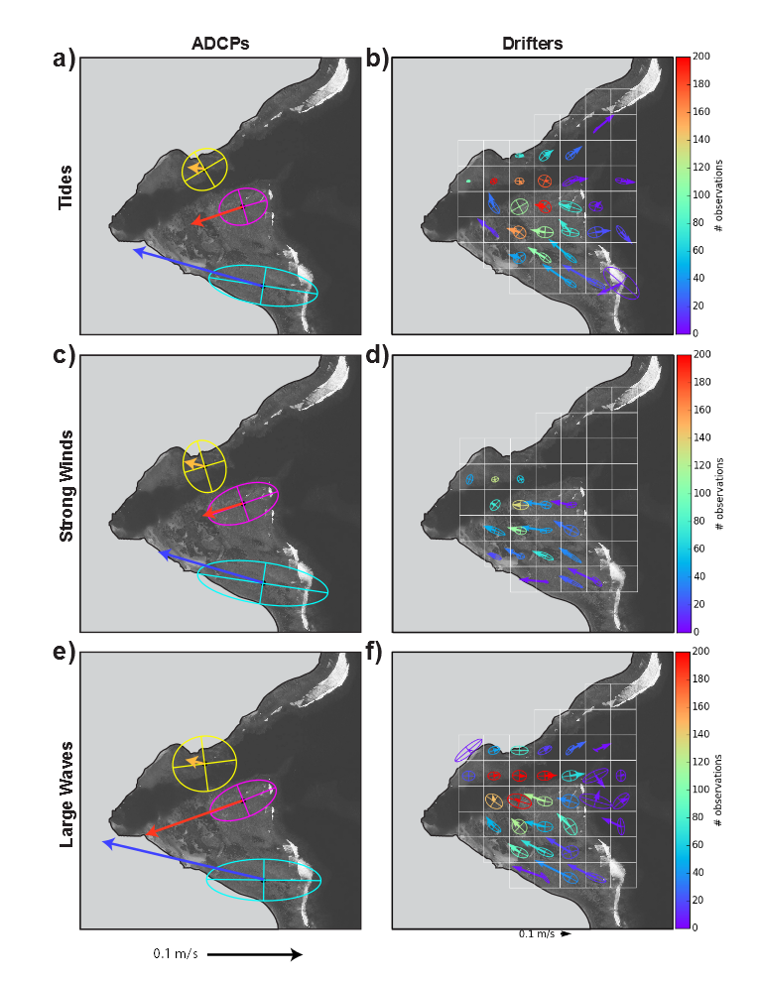

Figure 8. Empirical Orthogonal Functions (EOF) calculated from ADCP data, compared to EOFs calculated from spatially binned (100m x 100m grid cell) drifter data under different end member forcing conditions: tide, wind, wave. Drifter EOFs are colored by number of observations to illustrate varying data density.

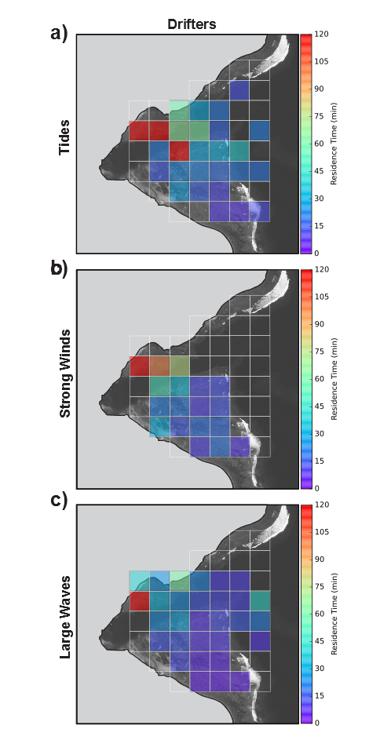

Figure 9. Residence time calculated from mean velocity of drifters under endmember conditions

|  |  |  |  |  |  |  |  |  |  |  |
| --- | --- | --- | --- | --- | --- | --- | --- | --- | --- | --- |
| **Table 1.** Drifter deployment dates and conditions. Red numbered Deployments coincide with ADCP deployment | | | | | | | | | | |
| Deployment | Year Day 2014 (local) | Start Time | End Time | Tide Start m | Tide End m | Tide movement m | Wind Speed Avg m/s | Wind Gust Max m/s | Wind Direction Avg deg | Wave Height m |
| 1 | 19 | 1300 | 1500 | 1.5 | 0.3 | -0.17 | 0.6 | 2.0 | 232 | 0.0-0.6 |
| 2 | 20 | 1615 | 1730 | 1.0 | 0.4 | 0.06 | 1.2 | 4.0 | 193 | 0.3-0.6 |
| 3 | 20 | 1750 | 1900 | 1.2 | 0.6 | 0.22 | 1.7 | 5.0 | 258 | 0.3-0.6 |
| 4 | 32 | 900 | 1100 | 3.7 | 0.8 | -0.35 | 2.7 | 6.0 | 96 | 0-0.3 |
| 5 | 32 | 1130 | 1300 | 2.2 | 0.3 | -0.41 | 2.9 | 7.0 | 100 | 0-0.3 |
| 6 | 32 | 1700 | 1900 | 1.5 | 1.0 | 0.52 | 2.2 | 7.0 | 187 | 0-0.3 |
| 7 | 39 | 1415 | 1545 | 3.1 | 1.1 | 0.11 | 2.7 | 9.0 | 140 | 0.6-1.3 |
| 8 | 39 | 1605 | 1800 | 3.3 | 0.8 | -0.24 | 3.1 | 10.0 | 144 | 0.6-1.3 |
| 9 | 47 | 1654 | 1846 | 2.4 | 1.0 | 0.26 | 1.7 | 5.0 | 168 | 0.0-0.6 |
| 10 | 48 | 1245 | 1500 | 1.6 | 0.3 | -0.16 | 5.0 | 14.0 | 79 | 0.6-1.3 |
| 11 | 48 | 1530 | 1700 | 1.1 | 0.5 | 0.14 | 3.0 | 10.0 | 101 | 0.6-1.3 |
| 12 | 48 | 1710 | 1840 | 1.6 | 0.8 | 0.29 | 2.7 | 8.0 | 89 | 0.6-1.3 |
| 13 | 49 | 1245 | 1445 | 2.1 | 0.4 | -0.25 | 2.5 | 7.0 | 97 | 0.6-1.3 |
| 14 | 49 | 1445 | 1700 | 1.3 | 0.4 | 0.02 | 2.4 | 8.0 | 194 | 0.6-1.3 |
| 15 | 50 | 1205 | 1440 | 2.9 | 0.5 | -0.42 | 3.0 | 6.0 | 39 | 0.6-1.3 |
| 16 | 50 | 1445 | 1720 | 1.5 | 0.4 | -0.08 | 3.4 | 8.0 | 54 | 0.6-1.3 |
| 17 | 51 | 840 | 1045 | 2.5 | 1.0 | 0.19 | 2.5 | 7.0 | 290 | 0.0-0.6 |
| 18 | 51 | 1100 | 1200 | 3.2 | 0.9 | -0.05 | 2.2 | 6.0 | 117 | 0.0-0.6 |
| 19 | 51 | 1210 | 1430 | 3.0 | 0.6 | -0.29 | 1.5 | 6.0 | 237 | 0.0-0.6 |
| 20 | 51 | 1500 | 1630 | 1.8 | 0.4 | -0.17 | 3.1 | 7.0 | 290 | 0.0-0.6 |
| 21 | 52 | 920 | 1040 | 2.4 | 0.9 | 0.18 | 1.5 | 6.0 | 253 | 1.0-2.0 |
| 22 | 52 | 1040 | 1145 | 3.0 | 1.0 | 0.09 | 2.0 | 6.0 | 111 | 1.0-2.0 |
| 23 | 52 | 1300 | 1400 | 3.2 | 0.9 | -0.08 | 1.5 | 8.0 | 193 | 1.0-2.0 |
| 24 | 52 | 1500 | 1550 | 2.4 | 0.6 | -0.16 | 1.9 | 6.0 | 152 | 1.0-2.0 |
| 25 | 53 | 1100 | 1215 | 2.7 | 1.0 | 0.14 | 2.8 | 7.0 | 313 | 1.0-2.0 |
| 26 | 53 | 1220 | 1315 | 3.2 | 1.0 | 0.05 | 3.3 | 6.0 | 301 | 1.0-2.0 |
| 27 | 53 | 1600 | 1700 | 2.4 | 0.6 | -0.16 | 2.1 | 5.0 | 310 | 1.0-2.0 |
| 28 | 53 | 1700 | 1845 | 1.9 | 0.4 | -0.22 | 1.0 | 5.0 | 242 | 1.0-2.0 |
| 29 | 54 | 1040 | 1210 | 2.0 | 0.9 | 0.27 | 3.7 | 8.0 | 304 | 0.6-1.3 |
| 30 | 54 | 1210 | 1255 | 2.9 | 1.0 | 0.11 | 2.7 | 6.0 | 260 | 0.6-1.3 |